**COUNSELOR’S CORNER NEWS**



***Mrs. LaRocca M.Ed., School Counseling***

**Guidance Lessons Weeks: 4/15/24-4/26/24**



**Social Emotional Learning Focus- Identifying Problems-Coming Up with Solutions**



**There are times when we need to talk to someone about a**

[**Proverbs 3:5**: "Trust in the Lord with all your heart, and do not lean on your own understanding.](https://www.openbible.info/topics/problem_solving)



**problem like something we did not like, something we need or**



**something we want. We can do this by using our words to say the**

**problem and then coming up with ideas on how to solve the problem**.

###### 

###### **Pre-K 3 & 4- Solutions-Solving the Problem**- We learned the first

###### step in problem solving is to use our words to say the problem. The

###### second step is to think of solutions (ideas) to solve the problem.

“Do not judge, so that you

will not be judged.  For with the judgment you make you will be judged, and the

measure you give will be the measure you get.

 (Matthew 7:1-2)

###### Then you can choose the best one.

**Kindergarten & 1st - Enemy Pie Book & Worksheet “Friendship Pie.”**

Itis sometimes hard to make new friends, but it is also rewarding.

when we do. We should not judge others (a book by its cover) before

giving them a chance and getting to know them. You may think someone

is your enemy until you spend the day with them. They may turn out to

be your best friend.

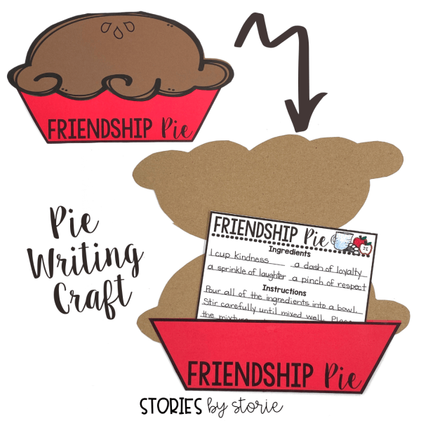

**2nd-5th- Enemy Pie Book & Recipe for Friendship Pie- It can be difficult making new friends but, in the end, very rewarding. You may think someone is your enemy but after spending time with them realize they are no different and we all have something in common. We should never judge others too quickly (judge a book by its cover). The true way to get rid of your enemy is to make them your friend.**



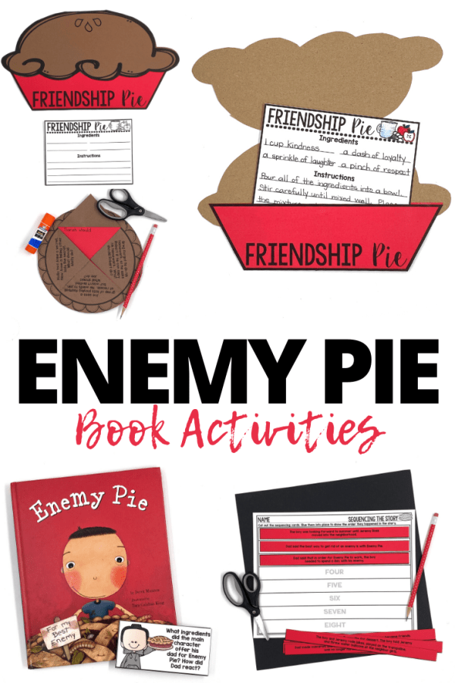

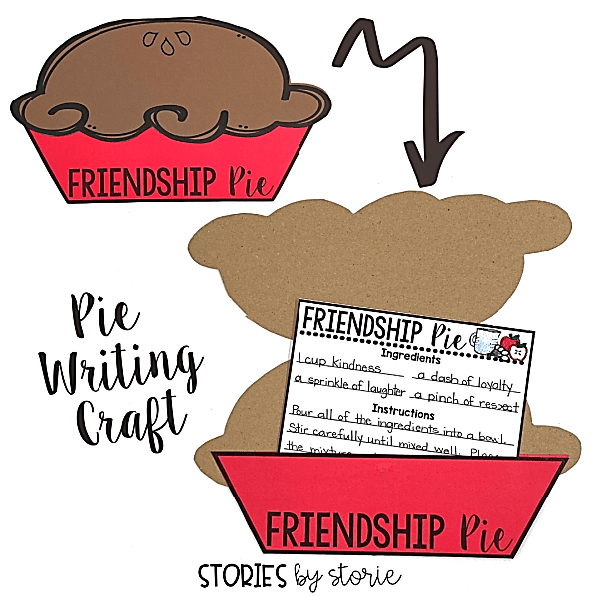

**6th, 7th, & 8th- Gossip & Rumors: What Would You Do?-** Gossip & Rumors Scenariotask cards. Students will explore different scenarios dealing with moral dilemmas (gossip/rumors) and ethical decision-making and consider their actions carefully before choosing how they will handle the situation. They will see the choices they make have consequences. Will their choices hurt someone? Will they affect their relationship with God and others?

